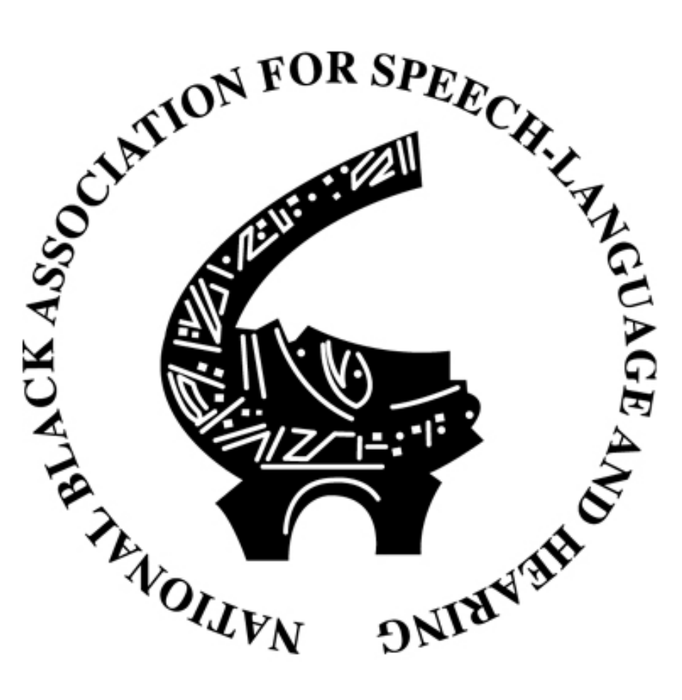
The National Black Association for Speech-Language and Hearing (NBASLH) Student Affiliate Chapter of UNC Greensboro

Membership Form
Membership Dues: $10

Name: _______________________________________________________________________

UNCG Email Address: _________________________________________________________

Classification (Check One):
❐ Freshman
❐ Sophomore
❐ Junior
❐ Senior
❐ Second Degree
❐ Graduate

Paid by (Check One): ❐ Venmo ❐ Cash ❐ Check

If paying with cash or check, please put the form money into an envelope and give it to an officer or place it in the NBASLH box in the front office of the UNCG Speech & Hearing Center.

If paying through Venmo, please email the form to NBASLH.UNCG@gmail.com and disclose that payment method.

Questions?
Email NBASLH.UNCG@gmail.com

