The Next Chapter
An Autism Spectrum University Course Curriculum
Jessica Elko - Stephanie Flowers - Sarah Wilkinson
Abstract
The purpose of this project is to create a functional curriculum based on school specific research that addresses the needs of the High Functioning Autistic and Aspergers Syndrome (HFA and AS) population. The formulated curriculum should be a useful tool to give the HFA/AS students training on the social communication skills that will be vital when seeking employment, creating and maintaining social relationships, and dealing appropriately with individuals in a professional manner. The addition of this curriculum will provide a solid basis of knowledge as well as a support team to guide these students from one phase of their lives to the next.
Table of Contents
Background Information 4
Prevalence of the HFA/AS Population: 5
Current University or Transitional Support Systems: 10
Typical Needs of the HFA/AS Population: 13
Curriculum 15
Syllabus 16
Calendar of topics 20
Class One 22
Lesson Plan 23
Materials 24
Class Two 36
Lesson Plan 37
Materials 38
Class Three 47
Lesson Plan 48
Materials 49
Class Four 50
Lesson Plan 51
Materials 52
Class Five 53
Lesson Plan 54
Materials 55
Class Six 60
Lesson Plan 61
Materials 62
Class Seven 63
Lesson Plan 64
Materials 65
Class Eight: 66
Lesson Plan 67
Materials 68
Class Nine 69
Lesson Plan 70
Class Ten 71
Lesson Plan 72
Materials 73
Class Eleven 74
Lesson Plan 75
Class Twelve 76
Lesson Plan 77
Materials 78
Class Thirteen 79
Lesson Plan 80
Materials 81
Class Fourteen 82
Lesson Plan 83
Materials 84
Class Fifteen 85
Lesson Plan 86
Assignments 87
Reflections 88
In Class Assignments 89
Group Poster and Presentation 90
Exams 92
Class Participation 93
Resource Manual 94
Definition: 95
Prevalence: 95
Causes: 96
Characteristics: 96
Scholarly Articles Related to College-Aged Students 97
Internet Websites/National Resources 98
Local Community Agencies 100
References 103

Background Information

Prevalence of the HFA/AS Population:

The first area of importance when looking at the prevalence of the HFA/AS population is to understand the demands on the educational system by looking at the current population size. The total prevalence of the Autism Spectrum population is 1 in 110 individuals with a total number of 1-1.5 million Americans.
The table below shows both the enrollment of total students and all students with disabilities at the North Carolina state level and the national level. It is important to note the entire population of students with disabilities to have an idea of the resources required to support this population.
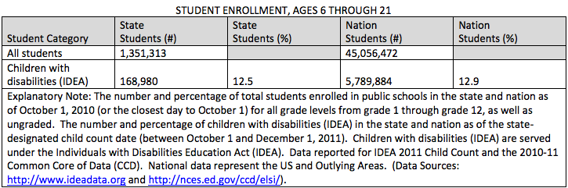

Next, the table below shows the percentage of enrolled students with Autism both at the North Carolina state level and the national level.

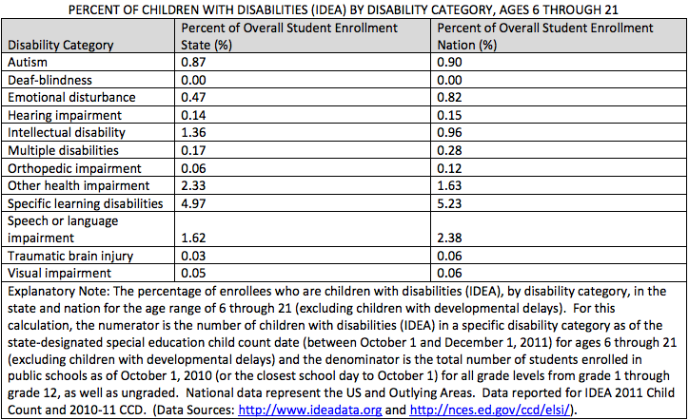

Now it is necessary to focus more specifically on the students who are enrolled at the secondary education level and who have graduated with a diploma. These students will be the population eligible for post-secondary education and is therefore the population that could potentially use this social communication intervention.
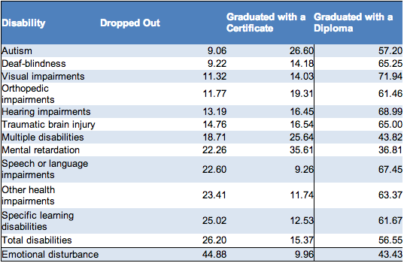

Finally, looking at the current students who have enrolled in post-secondary education, whether it is a transition certificate or actually being enrolled at the university or community college level, will give a good estimate of the current population that are being served in the higher education setting.
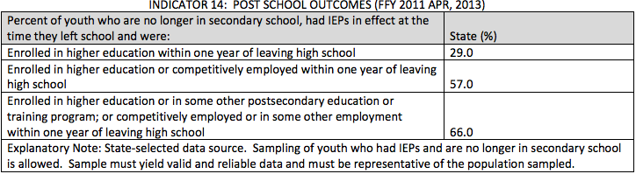

The second area of importance that must be investigated is if there are any trends, either increasing or decreasing, currently seen in this population. The main trend is in the overall number of diagnoses over the past two decades, which has increased dramatically. This influx of children requiring support could lead to a higher demand on the educational system in terms of support needed for these individuals. Below is a graph of the current trend. Diagnoses of autism spectrum disorders have increased dramatically over the past decades and are still climbing. Therefore, more support systems and helpful programs must be put in place to give this population the required scaffolding needed for success.
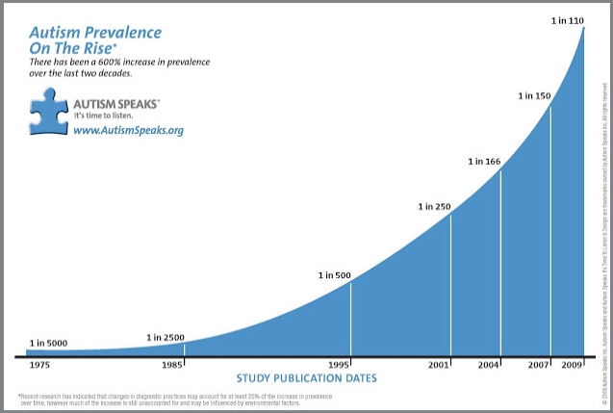

This graph shows the upward trend of the autism spectrum population based on age.
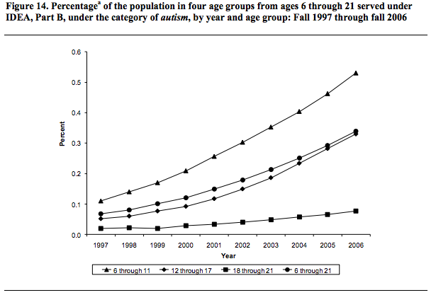
Once the basic trend is established, it is important to look at how other disabilities that will require extra educational support are trending. The table below shows that Autism Spectrum is the only disorder with a definite upward trend. The other disabilities listed, with the exception of other health impairments are remaining constant.

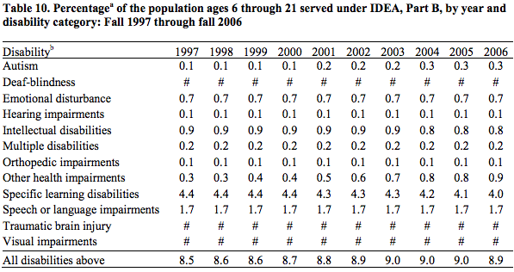

Another area to investigate is if there is an upward trend in the specific population of HFA/AS students who will be eligible for higher education programs. Students who graduated high school with a diploma are the most likely candidates for higher education.
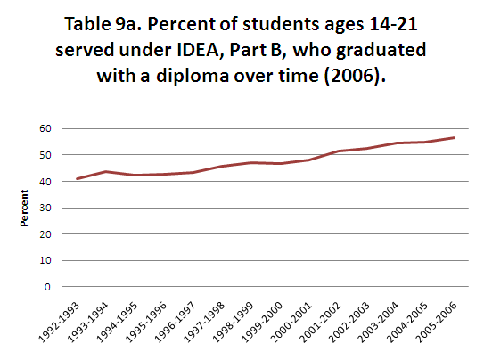
Another way to specifically target to HFA/AS population is to look at the percentages of students that spend the majority of their time in an inclusion setting. The table below shows a definite increase in the students that are spending time in the regular education classroom. This is caused by educators and educational settings becoming more accommodating for students with disabilities, so there are more students with Autism Spectrum Disorder that are getting more exposure to mainstream education. It is likely that the HFA/AS population that will later enroll in post-secondary educational settings will come from the group of students that were placed in the inclusion classroom early on in their educational development.

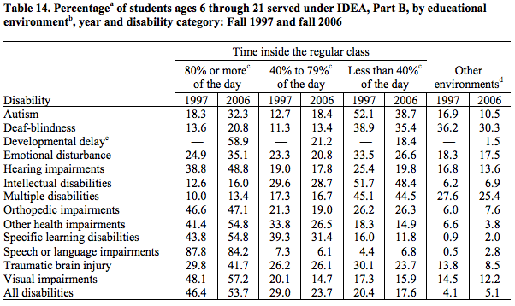

Current University or Transitional Support Systems:

There are many universities across the nation that offer programs for students with disabilities seeking post-secondary education. The table below only lists the current two and four year programs created specifically for the HFA/AS population.

Location | Name | Description | Cost Per Semester
Alabama | University of Alabama Autism Spectrum Disorders College Transition and Support Program | Comprehensive academic and behavioral supports | 3,000.00
Arkansas | University of Arkansas Autism Support Program | Comprehensive Services to students in the areas of academics, social skills, and transitioning to independent adult roles. | 5,000.00
California | Transition to Independent Living Program at Taft College | Post-Secondary program focused on independent living skills | Not Listed
Connecticut | University of Connecticut SEAD (Strategic Education for Students with ASD) Program | Comprehensive academic and behavioral supports | 3,000.00
Florida | Nova Southeastern University | Access Plus: a comprehensive program for academic, residential and vocational skills | 8,000.00
 | University of West Florida: Autism Inclusion Program | Provides academic, social, life skills, and career planning support to HFA and AS students | Not Listed
Iowa | The University of Iowa: Reach Program | two-year transition program for students with multiple intellectual, cognitive, and learning disabilities. | 6,250.00
Kentucky | Western Kentucky University | Student support and mentoring | 2,000.00
Maryland | Community College of Baltimore County-Essex Campus | Individual Student Support | Not Listed

Massachusetts | Boston University: Supported Education Services | Individualized assistance with skills and support | Current Tuition
 | Western New England University | Mentoring program in conjunction with ABA doctoral program and the department of Psychology
Michigan | Eastern Michigan University: Autism Collaborative Center | Individualized Support services | 8,500.00
New Jersey | Fairleigh Dickenson University: COMPASS Program | College-based support for students with HFA and AS | 3,000.00
 | Rutgers University | Full Support Services | 2,500.00
New York | Adelphi University: Bridges to Adelphi Program | Comprehensive academic, social, and vocational support services to students with HFA and AS | 2,500.00
 | Rochester Institute of Technology | Provides individualized support to students on the spectrum | Not Listed
Ohio | Defiance College: ASD Affinity Program | Comprehensive academic, social, and residential support services that assist students with ASD | 10,230.00
 | Wright State University: RASE Program | Individualized academic and social support services | No charge for qualifying students
Pennsylvania | Eastern University: College Success Program for Students Living with Autism Spectrum Disorder | Provides academic, social, life skills, and cultural supports for undergraduate students | 6,500.00
 | Mercyhurst | Program of support and mentoring | Not Listed
 | St. Joseph’s University: Student Success and Retention Program | Individual advisor, social worker, and psychologist on staff to provide bi-weekly meetings and support | 3,000.00
Tennessee | University of Tennessee at Chattanooga: MOSAIC Program | developed to support the holistic needs of the UTC students with ASD | Current Tuition
Washington | Bellevue College: Autism Spectrum Navigators Program | Provides support for the ASD student population | No charge for qualifying students
West Virginia | Marshall University: College Program for Students with HFA and AS | Positive behavior and academic support | 3,200.00

Typical Needs of the HFA/AS Population:
The basic needs of the HFA/AS population can be broken down into differences in the following areas:
Area of Difference: | Specific Issues: | Classroom Accommodations:
Communication skills | - Slower receptive processing: misunderstanding jokes, idioms, sarcasm, gestures and body language  - Expressive difficulties: initiations of conversations, topic maintenance, turn taking, organization, and voice tone/ volume. | - Providing the student with lecture notes and study guides  - Helping the student focus on the important information  - Allowing longer verbal response time for the student  - Instructions should be clear, concise, and logical
Social Skills | - Theory of Mind  - Eye Contact  - Personal space  - Difficulty understanding the unwritten classroom etiquette  - Some students with HFA/AS could have extreme social anxiety | - The instructor should:  - Allow a buffer or short brakes from group time to help reduce social anxiety  - Assist in the formation of classroom groups and monitor the student’s level of inclusion  - Provide written guidelines for social interaction in the classroom setting
Sensory Differences | - Under or oversensitivity to sensory stimuli: bright lights, too many individuals talking, painful textures, smells that cause “sensory overload”  - Synesthesia: actual information of one sense is accompanied by the perception in another sense (seeing music as color patterns) | - Allowing hats or sunglasses to block out light  - Letting the student choose his or her seat  - Allowing alternative note taking or test taking instrumentation (laptop, preferred types of paper)
Motor Skills | - Poor motor planning  - Fine motor skills: problems with writing, drawing, and manipulating small objects  - Gross motor skills: walking, balancing | - Allowing a computer in class  - Providing a note taker  - Slower pace of work assignments  - Providing step by step instruction and models
Learning Style | - Uneven learning profile  - Executive functioning problems  - Poor sequential learning  - Attention problems  - Nebulous sense of time  - Poor perspective taking | - Provide review sheets for lectures  - Create “Sub” deadlines/check-ins for extensive assignments  - Provide hands on learning  - Provide paired peer mentors  - Create a consistent classroom structure
Coping Skills | - Students with HFA/AS can have severe anxiety and stress  - Students may also be unable to express emotions such as excitement, happiness, anxiety, anger, frustration and confusion  - Can exhibit coping mechanisms such as rocking, pacing, flapping hands, and chewing clothing, hair, or skin, in order to cope with emotions | - Be aware of stressors  - Give the student an alternative way of coping  - Do not discourage or disrupt the behavior unless it is overly disruptive or unsafe  - Allow comfort items  - Create a cue for the student to alert you if he or she needs to leave

It is important to remember that the above listed difficulties and differences are not found in every person with HFA/AS. The autism spectrum population is a heterogeneous group. In order to treat and teach these individuals appropriately, the clinician should look at each individual in the classroom and find the similarities and differences in the group.
Another important note to be made is that HFA/AS students may be unable to verbalize what they require for an optimal learning environment. The needs of the student could be clearly indicated by coping mechanisms listed previously, or could be manifested by limited success in the classroom. It is important for the clinician or the educator teaching this population to understand that their students may need help to verbalize what is making them unsuccessful or upset in the classroom and to assist the student in eliminating or appropriately coping with the classroom issues.

Curriculum

Syllabus
The following is a sample syllabus for the course outlining long term objectives, assignments, classroom policies
University of North Carolina at Greensboro
Department of Communication Sciences and Disorders

Course Title: Social Communication | Semester/Year:
Course number: | Time of Class Meeting:
Instructor: | Instructor Email:
Office Location: | Class Location:
Instructor’s Office Hours: | Instructor’s Office Phone:

Course Syllabus

Prerequisites:
Admission to the University of North Carolina at Greensboro

Course Description:
This 3 semester hour undergraduate-level course focuses on social communication skills that will be vital when seeking employment, creating and maintaining social relationships, and dealing appropriately with individuals in a professional manner

Student Learning Outcomes: (Long Term Goals)
SLO1: Students will improve their understanding of classroom routine and etiquette, which will be assessed by in-class assignments, teacher observations, and student reflection.
SLO2: Students will improve social interaction and social communication skills through class lectures and group learning, which will be assessed by group projects, teacher observations, and participation grading.
SLO3: Students will manage course requirements with increased independence throughout the semester utilizing assignment aids, lecture information, and coping strategies, which will be assessed by all assignments, teacher observations, and the end of semester self-rating tool.

Assessment of Student Learning

Grading Policy
Total points for exam, presentations and assignments will be 500 points, distributed as follows:

Assignments/Exams | Number of Points
1. Reflections | 120 points
2. Group Project | 130 points
2. Midterm | 50 points
4. Final exam | 50 points
6. In-Class Assignments | 100 points
7. Class Participation | 50 points
Total | 500 points

Assignments are to be handed in on the due date. Assignments handed in after the due date will be late and 5 points will be deducted for each day overdue.

Description of Assignments:

Reflections:
You will be asked to write three 2-3 paragraph responses based on class topics. Grades will reflect content (demonstration of understanding of the class material and personal thoughts) and writing mechanics (e.g. spelling, grammar).
Purpose: As young adults, you will need to be able to communicate a wide range of ideas to a variety of people. The reflection topics have been chosen to help guide your thoughts and impressions on the subjects covered in class. These reflections are your own opinions. Personal stories and anecdotes are welcome!

Group Assignment:
This assignment is to be done in groups of 2 or 3 (not 4) that will be established early in the semester. The intention is for you to work together to complete the assignment. As a group, you will choose a topic of interest from a given list and will use the grading rubric as a guide to create a poster. Your grade will reflect both the content of the poster and a five minute presentation given by each member of the group. Poster presentation dates are listed on the course schedule. More information on this Project will be given over the course of the semester.

Midterm and Final Exams:
All tests will focus on material covered in class. Tests will be given on days indicated on the syllabus – the dates will not change. However, tests will only consist of the information we have had time to cover. There will be no make-up tests unless you give prior notice that you will be unable to be present for the test date. Therefore, if you miss a test without giving prior notice, you will receive a “0” for that exam. (50 points each test). The final exam will be a functional outing for the class. The students will go out and engage in a social setting. Students will be graded based on participation, relevance of contributions, and integration of course material.

Participation points:
A significant part of this course is devoted to social communication skills. Therefore, you are expected to contribute orally each and every class. That can be in the form of a question, response, or even an affirmation of another’s comment or question. This is a group effort so either everyone receives points, or no one receives points. You will receive a total of 50 points depending on the number of classes having full participation.

In-Class Assignments:
In class assignments will be given at the end of a classroom topic. The assignments will be completed individually or in groups. These assignments will be used to help organize and explain the course content discussed so far and will be turned in before the end of the class. These assignments will be graded on content (did you answer the questions/follow the instructions) and effort put forth during class to complete the assignment in the time given.

Grading Scale: (The total for the course of 500 points will be converted to a percentage for the final grade)

Letter Grade | A+ | A | A- | B+ | B | B- | C+ | C | C- | D+ | D | F
Percentage (%) | 100-98 | 97-94 | 93-90 | 89-87 | 86-84 | 83-80 | 79-77 | 76-74 | 73-70 | 69-67 | 66-60 | <60

Attendance & Classroom Policy:
To successfully complete this course, students will be required to complete assignments on time. Attendance for all class meetings and participation are essential to the integration of course material and the student’s ability to demonstrate proficiency. Please be thoughtful of other students in the class by arriving on time. If you carry a cell phone, please turn it off while you are in class. Attendance is required to ensure a thorough grasp of the information covered in lectures and in-class assignments. By missing class you will take the risk of missing important examination information. Students are allowed to have 2 absences without penalty to their grade. It is important for students to inform the instructors if they will be absent as soon as possible to arrange make-up assignments and for students to receive notes from the missed class.

Class participation and class preparation
Means to be punctual, participate actively and contribute to class and group discussions with substantial ideas and information, listen respectfully when others talk and not engage in private conversation. It also includes not doing work for another class, text-messaging, personal work on laptop or other instead of attending and participating. Class participation also includes being prepared by bringing in completed assignments on time, having materials necessary to participate in the class lessons, and having reviewed the course schedule to know what topic(s) will be covered that day.
Academic Integrity:
The UNCG Honor Code covers all of the work that you do for this class. It is your responsibility to be sure that you understand this policy concerning cheating, plagiarism, and other areas of academic dishonesty and the consequences for violation of this policy. Each student is required to sign the Academic Integrity Policy on all major work submitted for the course. Refer to the UNCG Graduate Bulletin or http://saf.dept.uncg.edu/studiscp/honor.html

Academic Support Services – Special Needs
UNCG provides assistance for “special needs” concerning factors that may seriously hamper your ability to attend and participate in class and to learn the material. It is your responsibility, however, to talk with me as soon as possible so that necessary arrangements can be implemented, and in the case of dyslexia or physical disability, to meet with a staff member at the Academic Skills Center.

Calendar of topics

(This course schedule is provisional. Any changes will be announced in class and posted under course information and/or announcements in Blackboard).

Date | Topic | Due
Class One | Class Etiquette: Syllabus review and getting to know the class
Class Two | Class Etiquette: Effective learning | Signed Syllabus  Syllabus Quiz
Class Three | Class Etiquette: University resources
Class Four | Class Etiquette: Working in groups | In-Class Assignment 1
Class Five | Class Etiquette: Classroom behavior and policy | Reflection 1
Class Six | Social Communication: social etiquette
Class Seven | Social Communication: UNCG social avenues | In-Class Assignment 2
Class Eight | Class vote | Exam 1
Class Nine | Social Communication: Communication across contexts | In-Class Assignment 3
Class Ten | Professional Communication: Interviews, resumes, applications  ******CLASS WILL MEET IN THE COMPUTER LAB****** | Reflection 2
Class Eleven | Professional Communication: Teachers, bosses, co-workers
Class Twelve | Professional Communication: Time management and scheduling | In-Class Assignment 4
Class Thirteen | N/A | Group Project Poster Presentations
Class Fourteen | N/A | Finishing Poster Presentations, In-Class Assignment 5
Class Fifteen | N/A | Reflection 3  Final Exam

Social Communication Class

After you have thoroughly read the syllabus, please fill out the information below and return to me.

Name (Print) ________________________________________________________________________________

Signature ________________________________________________________________________________

Class One

Lesson Plan

Class Meeting One – Classroom Etiquette – Syllabus Review and Getting to Know the Class
Specific HFA/AS Needs Targeted
Sensory differences, coping skills, learning styles, communication skills

Classroom Objectives
Student Name: | Accuracy | Objective Met (Yes/No)
Objective One: Student will be attentive in class with no more than ____redirections from clinician.
Objective Two: Student will participate in class discussions and/or activities ____% of the time.
Objective Three: Student specific goal

Classroom Activity | Materials
- Students will participate in an “icebreaker” activity  - Students will then work independently to complete the learning styles inventory  - Instructors will review the course syllabus and the expectations for the class (class policy)  - Additionally, the instructor will address any class questions as needed  - Instructors will begin a mini lesson “fun facts and information about the university: getting acclimated to your school”  - History about the university  - Fun facts and interesting blurbs  - The area around the university  - Review of class discussions  - Overview of upcoming assignments and topics  - Remind students to sign and bring in syllabus  - Review syllabus for quiz  - Bring in all other course syllabi for class two activity | - Ice Breaker Activity  - Syllabus  - Learning Styles Inventory

Materials
Ice Breaker Activity Ideas

There is a spectrum of autism, so be aware that some students will have an easier time than others. Autism often affects social skills as well as some delays in speech. Use multimodal cues to help students understand expectations and feel more willing to participate.

- Skittles activity: Every Skittle color has a “topic” assigned to it. Each student is given 3 Skittle candies (can choose flavor of their liking). After students have chosen their candies they are instructed to share/elaborate on the topic assigned to their Skittle color. Everyone takes turns and gets to enjoy their candy after they have shared!

- Best/Worst. Have each student share their best and worst moments from the previous week. Try to steer the group away from school items. This icebreaker is an easy one to use at first and gives you good feedback concerning their life at the moment…the answers become more honest as you go.

- Most Unique. Go around the room and have each person share something that makes them different from anyone in the group, like, “I’ve never left the state I was born in” or “I am one of ten kids.”

- Two Truths and a Lie. Have each person make three statements about themselves: two true statements and one lie. For example, “I’ve never broken a bone. I have five sisters. I was born in Yugoslavia.” The group tries to guess which statement is the lie.

- Deserted Island. Ask, “You’ve been exiled to a deserted island for a year. You are told you may take three things you want, apart from the essentials. What would you take and why?”

- House on Fire. Ask, “Your house is on fire, and everyone is safe. You have thirty seconds to run through the house and collect three or four articles you want to save. What would you grab? Why?” After everyone has done this, the group can discuss what they learned about the things they value.

Syllabus
See pages 16-20 above

Learning Styles Inventory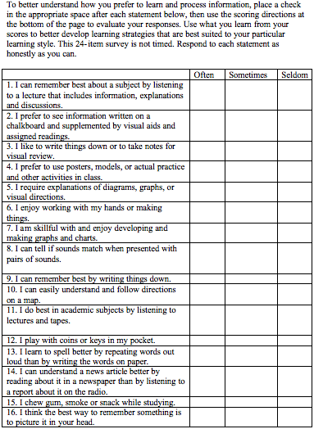

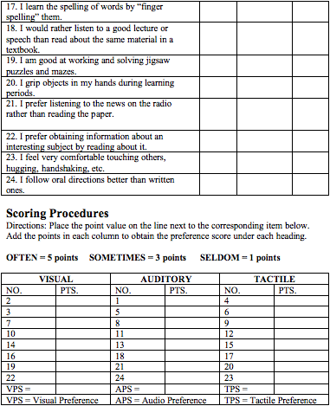

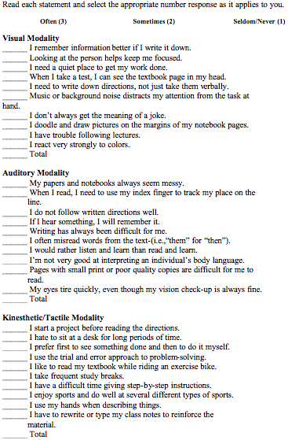
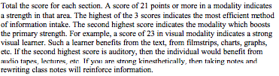
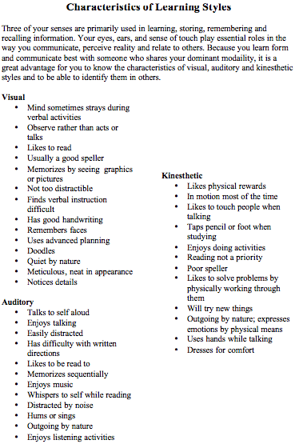
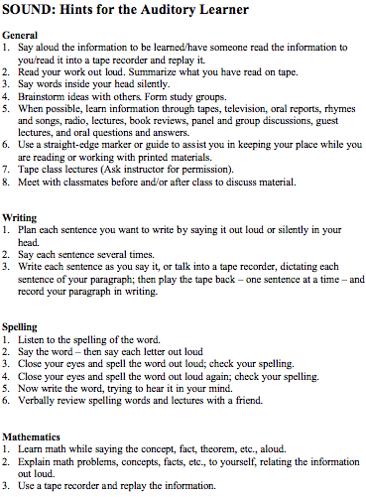
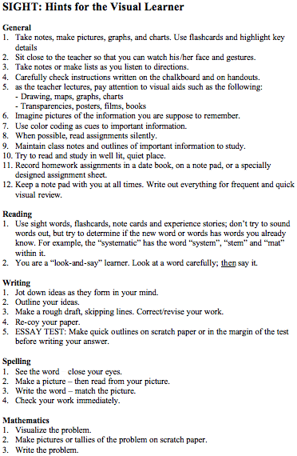
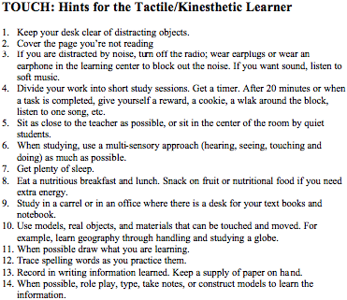

Learning Skills Inventory

Skill/Preference | Evaluation of Ability/Strength in Area:  Low Medium High
Study Skills: How would you rate yourself in the following study skills? Areas in which you rate yourself low may be topics of this web site you will want to explore; or you may wish to enroll in a study skills course to develop these skills.
Managing your time and study environment.
Reading textbooks.
Taking class notes.
Using information resources (library, internet, etc.).
Writing papers/completing projects.
Preparing for and taking exams.

Skill/Preference | Evaluation of Ability/Strength in Area:  Low Medium High
Learning Style: The categories below represent ways that you process information. Assess your "style" by determining how you learn best in most classroom situations. Regardless of how you rate in these areas, you should consider ways to develop "other" styles so that you will widen your range of expertise!
Visual: You learn best by "seeing" the concepts-- diagrams, flowcharts, time lines, films, and demonstrations.
Verbal: You learn best from reading, hearing spoken words, participating in discussion and explaining things to others.
Active/Tactile: You need to experience learning by "doing" or by getting personally involved.
Reflective: You need time to reflect on new information on your own and at your own pace.
Factual/Linear: You prefer information to be concrete, specific facts and data. You find it easiest to learn material presented step by step in a logical, ordered progression.

Factual/Linear: You prefer information to be concrete, specific facts and data. You find it easiest to learn material presented step by step in a logical, ordered progression.
Theoretical/Global: You are most comfortable with "big-picture" ideas, symbols, and concepts. You need to see the whole picture before details make sense to you. You easily "get" the patterns and relationships between ideas.
Skill/Preference | Evaluation of Ability/Strength in Area:  Low Medium High
Preferences: Considering these areas of preference will help you to determine where and when you should study for best results.
Persistence: This indicates your willingness to stick with a task even when you are uncomfortable or tired.
Verbal risk: This indicates your willingness to speak up in class, even when you are nervous about doing so.
Time: The time of day when you perform best: morning (low), afternoon (med.), or evening (high).
Grouping: Low would indicate your preference to learn or work individually; medium, in small groups; high, in large groups.
Mobility: Indicates your (low, medium, or high) need to move around and take breaks.
Sound: Do you need to study in areas where sound is low, medium, or high?
Lighting: Do you prefer low, medium or high amounts of light while reading or performing other study skills?
Temperature: Do you prefer a cool (low), medium, or warm (high) temperature?

Class Two

Lesson Plan
Class Meeting Two – Classroom Etiquette – Effective Learning
Specific HFA/AS Needs Targeted
Social skills, learning styles, communication skills, and coping skills

Classroom Objectives
Student Name: | Accuracy | Objective Met (Yes/No)
Objective One: Student will be attentive in class with no more than ____redirections from clinician.
Objective Two: Student will participate in class discussions and/or activities ____% of the time.
Objective Three: Student specific goal

Classroom Activity | Materials
- Hand in signed syllabus  - Syllabus quiz  - Distribute class planners  - Instructor will call on volunteer to share all of their course syllabi with the class. Student will then schedule and prioritize assignments as an example for the class assignment. Simultaneously students will spend 20 minutes organizing the current months coursework in the provided class planner.  - Mini lesson “Effective learning”  - Note taking skills  - Asking for clarification from instructor and/or classmate  - Class participation encourages understanding and attention to course material  - Effective study skills  - Forming a study group  - Test taking strategies  - “Pair and share” partner up and share your own strategies and then present one to the class  - Overview of upcoming assignments and topics | - Class planner  - Syllabus quiz  - Handout for “Effective learning” lesson

Materials
Student Planner:
Student Planner

University Name __________________________________
School Semester/Year ____________________________
Student Name _____________________________________

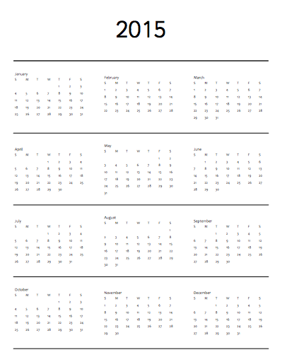

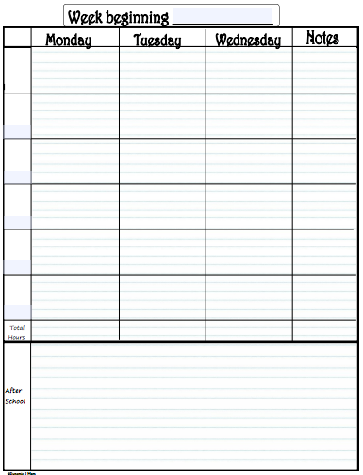

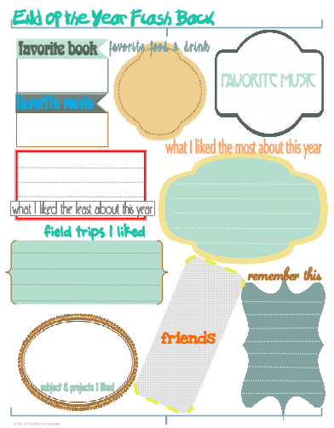

Syllabus Quiz:
The syllabus quiz will be a short, simple assessment to ensure that the students are familiar with the classroom policy, assignments, course calendar, and student objectives.

“Effective Learning” Lesson Handouts:
Time Management
- Start using a calendar, planner, or task list at the start of the semester.
- Write down important dates for exams, assignments and other projects on a calendar.
- Make a weekly or monthly schedule to get an overall picture of when you'll be busiest and when you have free time.
- Make a task list to keep track of things you need to do on a daily basis.
- Although some people like to use lots of tools to manage their time, it's not always necessary. Decide on one or two that will help you the most.
- Use short breaks in your daily schedule (such as an hour between classes) wisely. Schedule appointments on campus, check email or Courselink, or review your class notes.
- Break large tasks into smaller pieces that can be completed within a few hours (or even a few minutes).
- Procrastination happens, but don't let it take over your life. Pay attention to what makes you procrastinate and try to avoid these triggers, especially during high stress times.
- No one can - or wants to - study all the time! Plan your time to include doing things that you enjoy.
- Be patient and flexible. If certain time management strategies don't work for you, try a different strategy.
Listening and Notetaking
- Go to class — there's no substitute for the real thing.
- Find out how you'll be evaluated on the material from lectures. For example, are the lectures based on material from the textbook, or is the content entirely different?
- Come prepared to class by bringing printed copies of slides or lecture notes.
- Do assigned readings before the lecture in order to participate in class discussion, better follow the lecture, and ask meaningful questions.
- Disconnect your internet connection in class or leave your laptop at home.
- Listen actively by comparing what you hear in the lecture to what you learned in the last lecture, what you read in the textbook, or what you see on the slides.
- Concentrate to get the most out of the lectures. Sit where you can hear and see everything you need to.
- Organize your notes after the lecture by identifying main topics and key terms, underlining or using different colours for important points, and making diagrams or concept maps to illustrate relationships.
- Compare your notes with a study partner's notes on a regular basis in order to fill in missing information and identify what you know and what's unclear.
- Review your notes on a weekly basis to prepare in advance for exams.
Textbook Reading
- Find out how you'll be evaluated on your knowledge of the readings. For example, do you need to know the textbook inside out? Or is the text a supplement to the lectures?
- Think carefully about reading strategies and techniques that will help you the most in each course. Skimming, scanning, and in-depth methods can all be good reading strategies, depending on the course.
- Break long readings up into shorter, smaller chunks, depending on how long you can concentrate in that subject area. No one can read for hours at a time and remember details well.
- Find a quiet, comfortable place to read. Your body associates your bed with sleeping, so it's probably not the best place!
- Preview the reading by noting the subtitles and headings, looking at diagrams, and skimming through the introduction and summary.
- Reflect on the content as you read and take notes. How is the reading connected to the course lectures? In what way does it connect to the main ideas in the course?
- Pay attention to your attention span. Take a quick break if you can't remember what you just read.
- Summarize and take notes in you own words to help you understand and retain information. Don't rely on highlighting as your main method of note-taking.
- If you tend to read the textbook after a lecture, review your lecture notes before you read, and don't take additional notes on the material already well explained in your lecture notes.
- Review the notes from your readings on a regular basis to keep them fresh in your memory.
Exam Preparation
- Locate one or two good study places with few distractions or interruptions.
- Review the course outline for information about what your professor expects you to learn in the course.
- Review previous quizzes, assignments, papers, labs, etc. to pinpoint where you've had difficulty in the course. Make sure you understand that material since you may see it again in the next exam.
- Learn by doing. Do practice questions based on old exams, or create and answer your own test questions.
- Write practice exams under exam-like conditions (timed and with your books closed).
- Study in small chunks of time when possible. Two-hour blocks with a 15-minute break work well for many people.
- Study with a group if that works for you, but choose study partners who have the same general level of knowledge of course material and commitment to the course.
- Keep a regular schedule. Be sure to eat right, get enough sleep, and take time to exercise.
- During the exam, focus on what you do know rather than what you wish you had spent more time studying. Don't forget to breathe!
- After the exam is over, follow up. See the instructor or TA to find out how you can improve for next time.

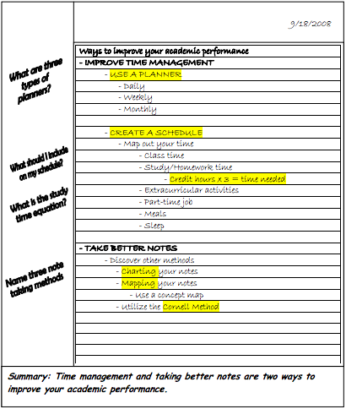

Class Three

Lesson Plan

Class Meeting Three – Classroom Etiquette – University Resources
Specific HFA/AS Needs Targeted
Communication skills, learning styles, coping skills, social skills

Classroom Objectives
Student Name: | Accuracy | Objective Met (Yes/No)
Objective One: Student will be attentive in class with no more than ____redirections from clinician.
Objective Two: Student will participate in class discussions and/or activities ____% of the time.
Objective Three: Student specific goal

Classroom Activity | Materials
- Brief class “survey” of students awareness of resources available on campus  - Lesson on “Resources at Your Fingertips: What UNCG has to Offer”  - Location of resources, classes, meeting areas, etc. at your school  - Facilitative Learning Resources, e.g. Writing Center, Speaking Center, Jackson Library, Financial Aid, etc.  - Professional Resources: Career Center, Networking, Special Guest speakers and seminars  - Instructors will then take the class on a tour of the campus, to the various sites mentioned in the previous lesson.  - Overview of upcoming assignments and topics  - Review grading rubric and expectations for In Class Assignment 1 next week | - Campus map

Materials
Campus Map
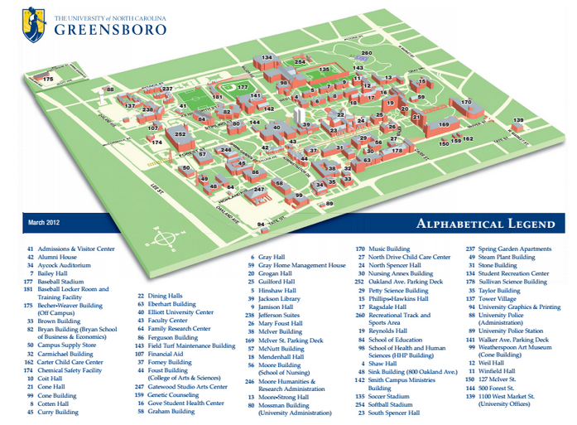

Class Four

Lesson Plan

Class Meeting Four – Classroom Etiquette – Working in Groups
Specific HFA/AS Needs Targeted
Communication skills, social skills, learning styles

Classroom Objectives
Student Name: | Accuracy | Objective Met (Yes/No)
Objective One: Student will be attentive in class with no more than ____redirections from clinician.
Objective Two: Student will participate in class discussions and/or activities ____% of the time.
Objective Three: Student specific goal

Classroom Activity | Materials
- Class discussion  - Contexts in which people work in groups  - Discuss pros and cons  - Lesson “Ingredients for successful group work”  - Respecting others opinions  - Communication  - Scheduling meeting times  - Evenly distribute workload  - Students as a class will choose 10 topics from a list and will sign up for a specific topic to present  - Instructors will help students divide into their respective groups, hand out group project outline sheet, and begin group project  - get to know group members  - exchange contact information  - create outline of topic  - assign roles  - plan next group meeting  - In class assignment 1: Turn in group name, topic, and outline  - Overview of upcoming assignments and class topics  - Reflection 1 due next week | - Group Outline  - Contact Sheet for group Members

Materials
Group Project Outline and Member Contact Information Sheet:
Group Name:
Group Topic:
Group Members:

Group Topic Subsections and Member Assignments:
Subsection 1:
Group Member Responsible:
Subsection 2:
Group Member Responsible:
Subsection 3:
Group Member Responsible:
Subsection 4:
Group Member Responsible:

Next Group Meeting:
Time:
Date:
Location:

Group Member Contact Information:
Group member Name: _____________________Phone #: __________________Email ______________________
Group member Name: _____________________Phone #: __________________Email ______________________
Group member Name: _____________________Phone #: __________________Email ______________________
Group member Name: _____________________Phone #: __________________Email ______________________

Class Five

Lesson Plan

Class Meeting Five – Classroom Etiquette – Classroom Behavior and Etiquette
Specific HFA/AS Needs Targeted
Coping skills, communication skills, social skills, learning styles

Classroom Objectives
Student Name: | Accuracy | Objective Met (Yes/No)
Objective One: Student will be attentive in class with no more than ____redirections from clinician.
Objective Two: Student will participate in class discussions and/or activities ____% of the time.
Objective Three: Student specific goal

Classroom Activity | Materials
- Class discussion: What do you think are the do’s and don’ts of in class behavior?  - Lesson: “Who stole the cookie from the cookie jar?”  - Appropriate behaviors in the class  - Turning in assignments on time  - showing appropriate respect to classmates and instructor  - Campus policies, i.e., academic integrity, cheating, plagiarism, etc.  - How to cite  - Have the class read and discuss various real-life scenarios of classroom behaviors and campus policy violations  - Fill out citation worksheet  - Overview of upcoming assignments and topics  - Review any lingering questions for the In Class Assignment 2 next week | - Scenarios  - Citation Worksheet

Materials
Classroom Behavior and Campus Policy Scenarios

- You are sitting in class when your phone goes off. The teacher is trying to give a lesson and your ringtone is loud. What should you do?
- Another student in the class makes an observation that you do not agree with. You want to argue your opinion. What are some good strategies for debating your opinion without being rude or critical?
- Your mom is supposed to call you with some very important news regarding a sick relative. She might call during class. Should you, a) keep your phone on vibrate and leave when it rings to answer, b) answer the phone in class, the teacher should understand it’s an important call, c) do not answer the phone until after class, or d) tell your instructor prior to the beginning of class that you are expecting an important call and ask if it would be ok if you answered it out in the hall. Explain your choice.
- What are some ways to avoid missing important assignments? Do you have any strategies that have worked well for you in the past?
- Your friend in class comes up to you a few minutes before class starts and asks to copy down your answers from the homework. She completely forgot to do it last night. Is that cheating? How would you answer her?
- Your friend feels really swamped with all of the work for his classes. He asks if you would meet with him to help him understand an upcoming difficult assignment and give him some advice about how to complete it. Is that against campus policy? Why or why not?
- What types of plagiarism exist and how do you avoid them?
  - State and explain 4 ways plagiarism can occur without citing a source.
  - State and explain 3 ways plagiarism can occur even if the source is cited.
  - What is one method to avoid plagiarism when paraphrasing someone's original ideas?
  - What are the steps involved in planning and writing a research paper to avoid plagiarism?
- How can you prevent plagiarism?
  - Define the following terms: common knowledge, corporate author, intellectual property, re-expression, and sponsoring organization.
  - What are some good scholarly habits when writing a paper?
  - Describe two note taking strategies that can reduce the chance of plagiarizing another's work.
  - What criteria must be met for information to be considered common knowledge?
  - What actions can you take to protect yourself from an ever changing online environment?
- True Stories!
  - Britney Spears - Apparently, Britney Spears’ stardom doesn’t place her above publishing and/or copyright law. On May 5, 2005, songwriter Steve Wallace appeared in federal court to file a lawsuit against both Spears and Sony/BMG Music Publishing, Inc. His assertion: he, and not pop diva Spears, penned the song "Sometimes" which appears on both Spears' Baby One More Time and Greatest Hits albums. Although Wallace did not formally copyright his song until 2003, he had, in fact, mailed a copy of the song to himself in a sealed envelope prior to the song being recorded. In addition to this “poor man’s copyright,” Wallace has demonstrated how his version of the song is virtually identical to the number Spears popularized. The case has yet to be settled.
  - Michael Bolton - Singer/songwriter Michael Bolton enjoyed much popular success in the 80s and 90s. Renowned for soulful remakes of Motown classics When a Man Loves a Woman, and (Sittin' on the) Dock of the Bay Bolton’s legacy is nonetheless tainted with the stigma of plagiarism. In 2000, the 9th Circuit Court upheld an earlier verdict that Bolton's 1991 song, "Love Is a Wonderful Thing" was too similar to the 1964 Isley Brothers song's "Love is a Wonderful Thing." Bolton had sold more than 10 million copies of the recording world-wide. As a result of the ruling, the jury awarded the original artists $5.4 million for copyright infringement. This remains the largest payout for copyright infringement in the music industry.
  - Kaavya Viswanathan - Sophomore Harvard University student Kaavya Viswanathan received much praise for her debut novel How Opal Mehta Got Kissed, Got Wild and Got a Life. However, not long after the young author began to collect royalties for her work, it was revealed that she had plagiarized. More specifically, she cut-and-pasted whole sections of text from Megan F. McCafferty's novels Sloppy Firsts (2001) and Second Helpings (2003), as well as authors Sophie Kinsella, Salman Rushdie, and Meg Cabot. Viswanathan apologized for her "internalization" of other authors' language and the "inadvertent" copying which had occurred. As a result of her plagiarism, publisher Little Brown recalled the book and nixed plans to publish a sequel. Additional fallout from the scandal brought criticism of the publishing company, which was accused of bolstering the bright student’s ambitions.
- Plagiarism Identification
  - Original Passage: At the start of the Great Depression, many Americans wanted to believe that the hard times were only temporary.
  - Plagiarism or Not: At the beginning of the Great Depression, a lot of Americans wanted to think that the hard times would be only temporary
  - Original Passage: Devices in the iPod range are primarily digital audio players, designed around a central click wheel – although the iPod shuffle has buttons also
  - Plagiarism or Not: An iPod is an MP3 player that lets you choose and play songs to listen to using a click wheel (or on older versions, buttons)
  - Original Passage: He was a very silent man by custom.
  - Plagiarism or Not: He was a usually quiet person.
  - Original Passage: A letter of thanks is a courteous acknowledgement of a gift or of something that was done for you.
  - Plagiarism or Not: A thank you note is a polite acknowledgement of a present or something nice someone did for you.

Citation Worksheet

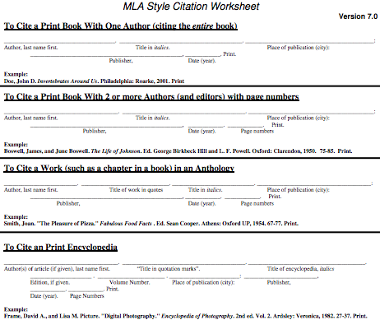
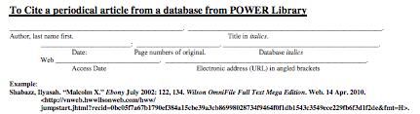
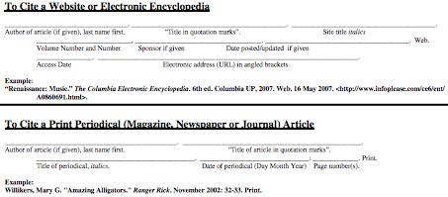
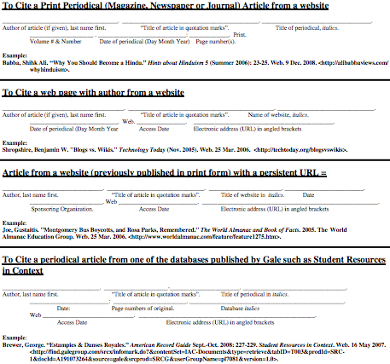

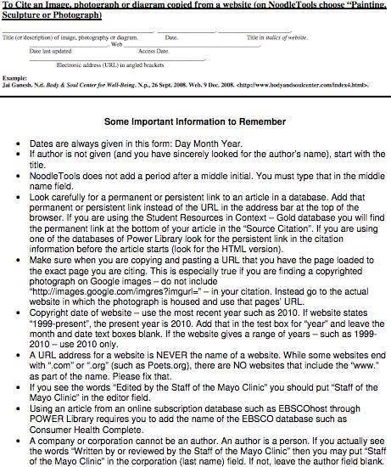

Class Six

Lesson Plan

Class Meeting Six – Social Communication – Social Etiquette
Specific HFA/AS Needs Targeted
Social skills, communication skills, coping skills

Classroom Objectives
Student Name: | Accuracy | Objective Met (Yes/No)
Objective One: Student will be attentive in class with no more than ____redirections from clinician.
Objective Two: Student will participate in class discussions and/or activities ____% of the time.
Objective Three: Student specific goal

Classroom Activity | Materials
- Class discussion: Scenario- “You are with a friend grabbing coffee, when she informs you that she has been very upset about a situation with her boyfriend.”  - Instructors lead discussion on how to approach/react to this situation and develop best/worst reactions and discuss in depth as a class  - Lesson: “To speak or not to speak”  - How to handle emotionally charged conversations  - How to show empathy  - How to approach delicate subjects in a non-offensive way  - How to share your worries, doubts, stressors, etc.  - Social media etiquette  - In Class Assignment 2: Students will be presented with multiple scenarios, which arrived from “social media” dilemmas (rumors on facebook, inappropriate pictures effecting future employment, overuse/reliance on social media). Students must tackle each dilemma with appropriate problem solving steps based on class topics and discuss in small groups.  - Overview of upcoming assignments and topics  - Review any lingering questions for the In Class Assignment 2 next week | - Social Media Scenarios

Materials

Social Media Etiquette Scenarios:
Scenario 1: While on Facebook, you see that a friend posted a picture of you that you do not want to be public. It could hurt your reputation or even make an employer upset. What steps would you take to talk to your friend about taking the picture down? What if your friend refuses?

Scenario 2: Your friends and family have mentioned several times recently that you seem to be on Pinterest “all the time.” You think about it and realize that they are probably right, you spend close to two hours a day on Pinterest, What do you think would be an appropriate time to spend on social media sites and how would you budget your time appropriately?

Scenario 3: You get on Facebook chat and see that a friend is online. You type “hey” hoping to start a conversation with your friend, but he/she doesn’t answer. What do you think is the appropriate reaction to this?

Scenario 4: A boy in your class has been spreading unkind rumors about you on twitter. These tweets have been going on for a few weeks now. What do you think is the best course of action to deal with this?

Class Seven

Lesson Plan

Class Meeting Seven – Social Communication – UNCG Social Avenues
Specific HFA/AS Needs Targeted
social skills, coping skills, communication skills, sensory differences

Classroom Objectives
Student Name: | Accuracy | Objective Met (Yes/No)
Objective One: Student will be attentive in class with no more than ____redirections from clinician.
Objective Two: Student will participate in class discussions and/or activities ____% of the time.
Objective Three: Student specific goal

Classroom Activity | Materials
- Discussion: What do you know about what your university has to offer for entertainment?  - Have the class discuss what programs/events the university has to offer  - Lesson: “Let the good times roll!”  - University sporting events: where to get current game schedules, dealing with crowds, being a good sport, etc.  - Theater/drama: campus movie nights, plays and musicals, etc.  - The Arts: Witherspoon gallery, Tate street festival, etc.  - Social gatherings: First year experience, homecoming, etc.  - In Class Assignment 2: Planning an outing  - Schedules  - Invites  - Traffic  - budget  - Overview of upcoming assignments and topics  - Exam 1 overview of expectations and question types/examples | - Schedules for social events at UNCG

Materials
Schedules for UNCG Social Events
Schedules for social events will differ from year to year. Use the university navigation to find links to sports events, theatrical performances, dinners, festivals, etc. on the UNCG website

Class Eight:

Lesson Plan

Class Meeting Eight – Social Communication – Class Vote
Specific HFA/AS Needs Targeted
Assessment of coping skills, communication skills, learning styles, sensory differences

Classroom Objectives
Student Name: | Accuracy | Objective Met (Yes/No)
Objective One: Student will be attentive in class with no more than ____redirections from clinician.
Objective Two: Student will participate in class discussions and/or activities ____% of the time.
Objective Three: Student specific goal

Classroom Activity | Materials
- Exam One: instructors will administer an exam to assess current levels, carryover, progress from baseline (as obtained from the learning styles inventory), etc.  - Following the exam, students will decide what to do following the exam (work on group project, class discussion of topics, etc)  - Overview of upcoming assignments and topics  - In Class Assignment 3 | - Exam

Materials

Exam One:
Exam One should be used to assess the student’s ability to follow directions, utilize time management skills, recall information addressed in previous classes, and apply their knowledge in a real-life scenario. Exam One can be used as a prescriptive assessment to monitor student’s progress through the course and modify or create any augmentative strategies to address any holes in the students’ learning. Possible topics for Exam One questions are as follows:
- Important classroom policies addressed on the syllabus
- Note taking and studying techniques discussed in class
- Current academic resources offered at the university
- Techniques to work in a group discussed in class
- Classroom behaviors that are both appropriate and inappropriate
- University policies on cheating, plagiarism, etc.
- Techniques for social conversations
- Social media etiquette questions
- University social resources available and how to access them
- Several functional scenarios about the above topics that require the students’ to engage in the material and reflect on personal relevance
These topics can be assessed using multiple choice, true false, fill in the blank, listing, and short answer questions.

Class Nine

Lesson Plan

Class Meeting Nine – Social Communication – Communication Across Contexts
Specific HFA/AS Needs Targeted
Social skills, communication skills, coping skills

Classroom Objectives
Student Name: | Accuracy | Objective Met (Yes/No)
Objective One: Student will be attentive in class with no more than ____redirections from clinician.
Objective Two: Student will participate in class discussions and/or activities ____% of the time.
Objective Three: Student specific goal

Classroom Activity | Materials
- Class Discussion: What kinds of communication situations make you uncomfortable, what situations are easy for you?
- Lesson: “The sacred personal space bubble”
  - Personal space based on relationship with the individual
  - Tools to assess your own conversation, is it dragging? Is it going in circles? Etc.
  - Turn taking
  - Topic maintenance
  - Be mindful of the interest of your listener
  - Speaking in front of groups, class presentation tips and tricks
- In Class Assignment 3: “Getting ready for the Group presentations”
  - Students will break into small groups
  - Each student will introduce their presentation topic to their groups in five minutes or less
  - Other members of the group will provide feedback, making sure to utilize skills from class four
- Review upcoming assignments and topics
  - Reflection 2 due date
  - Class location for next week.

Class Ten

Lesson Plan

Class Meeting Ten – Professional Communication – Interviews, Resumes, Applications
Specific HFA/AS Needs Targeted
Social skills, communication skills, coping skills

Classroom Objectives
Student Name: | Accuracy | Objective Met (Yes/No)
Objective One: Student will be attentive in class with no more than ____redirections from clinician.
Objective Two: Student will participate in class discussions and/or activities ____% of the time.
Objective Three: Student specific goal

Classroom Activity | Materials
- Class meeting will be in a computer lab to do the career aptitude test and hear from the guest speaker  - Students will turn in Reflection 2  - Class discussion: “What types of professions interest you, how will you prepare for this job, etc.  - Students will fill out a career aptitude test  - Based on the results of the test, the students will break into similar job groups and discuss responsibilities, environments, job hunting processes, etc.  - Guest Speaker from the career center  - Guest speaker will address resumes, interview skills, application processes, etc.  - Class will pair up and take turns interviewing each other for their desired position  - Review of upcoming assignments and class topics. | - Career Aptitude Test

Materials
Career Aptitude Test:
The following link will take the students to a career aptitude test that evaluates their skills, interests, style, and values to find several career options for them: http://www.whatcareerisrightforme.com/career-aptitude-test.php

Class Eleven

Lesson Plan

Class Meeting Eleven – Professional Communication – Teachers, Bosses and Coworkers
Specific HFA/AS Needs Targeted
social skills, communication skills, coping skills

Classroom Objectives
Student Name: | Accuracy | Objective Met (Yes/No)
Objective One: Student will be attentive in class with no more than ____redirections from clinician.
Objective Two: Student will participate in class discussions and/or activities ____% of the time.
Objective Three: Student specific goal

Classroom Activity | Materials
- Discussion: Job Experience
  - Class will discuss current and past job experience
  - Question and answer session
- Lesson: “dealing with the reality of being an adult”
  - Teachers: scheduling a meeting, getting contact information, appropriate ways of contacting your professor, dealing with personality and teaching style differences, disputing grades, etc.
  - Bosses: dealing with different personalities, handling negative situations in a professional manner,
  - Coworkers: dealing with different personalities, establishing relationships, refer back to class four for group etiquette, effective communication for a productive work environment
- Review upcoming assignments and topics
  - In Class Assignment 4 next week
  - Group Poster Presentations in two weeks

Class Twelve

Lesson Plan

Class Meeting Twelve – Professional Communication – Time Management and Scheduling
Specific HFA/AS Needs Targeted
coping skills, communication skills, social skills

Classroom Objectives
Student Name: | Accuracy | Objective Met (Yes/No)
Objective One: Student will be attentive in class with no more than ____redirections from clinician.
Objective Two: Student will participate in class discussions and/or activities ____% of the time.
Objective Three: Student specific goal

Classroom Activity | Materials
- Discussion: scenario “Balancing academic, professional and social life”  - You have an exam in a week, your cousin is getting married this weekend, and your boss just called to ask if you could cover an extra shift tomorrow, what would you do?  - Lesson: “Getting your ducks in a row”  - Methods for organizing and scheduling your life  - Where is the balance between work, school, and academics  - Understanding your limits, when is it time to say no and avoid overloading your life  - In Class Assignment 4:  - Break into groups and pick three was to effectively manage your time (e.g. planners, reminders on your phone, etc)  - Present the best ideas to the class  - Review upcoming assignments and topics  - Group Poster Presentations | - Planner print offs

Materials
Daily Planner Printables:
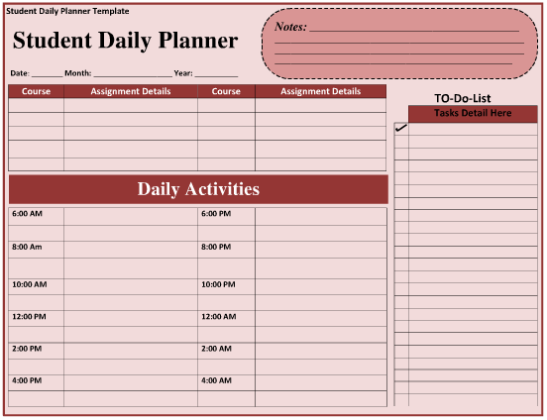

Class Thirteen

Lesson Plan

Class Meeting Thirteen – Group Project Presentations
Specific HFA/AS Needs Targeted
Assessment of coping skills, communication skills, learning styles, social skills and sensory differences

Classroom Objectives
Student Name: | Accuracy | Objective Met (Yes/No)
Objective One: Student will be attentive in class with no more than ____redirections from clinician.
Objective Two: Student will participate in class discussions and/or activities ____% of the time.
Objective Three: Student specific goal

Classroom Activity | Materials
- Class will present on their group topics  - Class will critique and discuss group presentations, focusing on positive feedback and tactful criticism  - Review of upcoming assignments and topics  - Finishing Group Poster Presentations  - In Class Assignment 5 next week | - Student Grading Rubric

Materials
Student Grading Rubric:

Grade | Participation | Addressing the topic | Content | Personal Presentation
Level 1: 70 points | Student is fully engaged in the presentation, respectful of other’s opinions, does not use electronics or other devices during class, comments or questions show reflection of class topics | Student addressed the group topic fully drawing information from personal response and class discussions and demonstrate their growth and reflection on class content | The student demonstrates thorough engagement with the important issues raised in class topics and discussions | Student is dressed appropriately, presents their information in a professional, concise manner, and shows good oral presentation skills
Level 2: 35 points | Student is sometimes engaged in the presentation, respectful of other’s opinions, does not use electronics or other devices during class, comments or questions show some reflection of class topics | Student addressed the group topic with relatively few personal responses and shows limited growth and reflection on course content | The student demonstrates limited engagement with the important issues raised in class topics and discussions | Student is dressed appropriately, presents their information in a somewhat professional, concise manner, and shows average oral presentation skills
Level 3: 10 points | Student is rarely engaged in the presentation, can be disrespectful of other’s opinions, occasionally use electronics or other devices during class, infrequently comments or asks questions, and does not show reflection of class topics | Student addressed the group topic with no personal response or reference to class discussion and topics | The student demonstrates no engagement with the important issues raised in class topics and discussions | Student is not dressed appropriately, presents their information in an unprofessional, ineffective manner, and shows poor oral presentation skills

Write the group name you are grading, then circle the level the group achieved based on the descriptions above. Once you have finished grading the group total up the amount.
Group Name:  ___________________ | Participation: Level 1  Level 2  Level 3 | Topic:  Level 1  Level 2  Level 3 | Content  Level 1  Level 2  Level 3 | Presentation:  Level 1  Level 2  Level 3 | Totals:  1 2 3 4  1 2 3 4  1 2 3 4
Group Name:  ___________________ | Participation: Level 1  Level 2  Level 3 | Topic:  Level 1  Level 2  Level 3 | Content  Level 1  Level 2  Level 3 | Presentation:  Level 1  Level 2  Level 3 | Totals:  1 2 3 4  1 2 3 4  1 2 3 4
Group Name:  ___________________ | Participation: Level 1  Level 2  Level 3 | Topic:  Level 1  Level 2  Level 3 | Content  Level 1  Level 2  Level 3 | Presentation:  Level 1  Level 2  Level 3 | Totals:  1 2 3 4  1 2 3 4  1 2 3 4
Group Name:  ___________________ | Participation: Level 1  Level 2  Level 3 | Topic:  Level 1  Level 2  Level 3 | Content  Level 1  Level 2  Level 3 | Presentation:  Level 1  Level 2  Level 3 | Totals:  1 2 3 4  1 2 3 4  1 2 3 4

Class Fourteen

Lesson Plan

Class Meeting Fourteen – Group Presentations
Specific HFA/AS Needs Targeted
Assessment of coping skills, communication skills, learning styles, social skills and sensory differences

Classroom Objectives
Student Name: | Accuracy | Objective Met (Yes/No)
Objective One: Student will be attentive in class with no more than ____redirections from clinician.
Objective Two: Student will participate in class discussions and/or activities ____% of the time.
Objective Three: Student specific goal

Classroom Activity | Materials
- Class will present on their group topics  - Class will critique and discuss group presentations, focusing on positive feedback and tactful criticism  - In Class Assignment 5: Students will use a grading rubric provided to grade their own presentations as well as other classmates to be turned in at the end of the class  - Review upcoming assignments and topics  - Reflection 3 due  - Final exam, review expectations and grading rubric, answer any questions | - Student Grading Rubric

Materials
See Student Grading Rubric under lesson 13 materials

Class Fifteen

Lesson Plan

Class Meeting Fifteen – Final Exam
Specific HFA/AS Needs Targeted
Assessment of coping skills, communication skills, learning styles, sensory differences

Classroom Objectives
Student Name: | Accuracy | Objective Met (Yes/No)
Objective One: Student will be attentive in class with no more than ____redirections from clinician.
Objective Two: Student will participate in class discussions and/or activities ____% of the time.
Objective Three: Student specific goal

Classroom Activity | Materials
- Exam Two: Class and instructors will participate in an outing. Students will be assessed based on the grading rubric given. Students’ grade will be heavily effected by their carryover of previous lessons and their participation on the outing.

Assignments

Reflections

All three reflection prompts are the same, but the responses should be different for each of the three reflections.

Reflection Prompt: Write down a positive or negative social/academic/professional experience you have had recently and how you approached it and applied class topics and information.
Grade | Writing Mechanics | Addressing the Topic | Content of the Reflection
Level 1: 40 points | Very good command of conventional English mechanics and has some originality | Student answered the topic question fully drawing information from personal response and class discussions and demonstrates author’s growth and reflection on class content | The reflection demonstrates thorough engagement with the important issues raised in class topics and discussions
Level 2: 20 points | Fairly good command of standard English, very few errors, no problems for the reader | Student answered the topic question with relatively few personal responses and shows limited growth and reflection on course content | The reflection demonstrates limited engagement with the important issues raised in class topics and discussions
Level 3: 10 points | The reflection uses incorrect grammar and vocabulary inconsistently, making it difficult for others to follow | Student answered the topic question with no personal response or reference to class discussion and topics | The reflection demonstrates no engagement with the important issues raised in class topics and discussions

In Class Assignments

- Assignment 1: Students will work in their presentation groups to create their group name, topic and outline to be handed in by the end of class
- Assignment 2: Students will be presented with multiple scenarios, which arrived from “social media” dilemmas (rumors on facebook, inappropriate pictures effecting future employment, overuse/reliance on social media). Students must tackle each dilemma with appropriate problem solving steps based on class topics and discuss in small groups.
- Assignment 3: Students will break into small groups. Each student will introduce their presentation topic to their groups in five minutes or less, after which, other members of the group will provide feedback, making sure to utilize skills from class four
- Assignment 4: The Students will break into groups and pick three ways to effectively manage their time (e.g. planners, reminders on the phone, etc) and will present the best ideas to the class
- Assignment 5: The students will grade themselves and their classmates on their group presentations using a provided grading rubric to be turned in at the end of class
Grade | Class Participation | Topic Relevance | Content
Level 1: 20 points | Student is fully engaged in activities, respectful of other’s opinions, does not use electronics or other devices during class, comments or questions show reflection of class topics | Student addressed the topic fully drawing information from personal response and class discussions and demonstrate their growth and reflection on class content | The student demonstrates thorough engagement with the important issues raised in class topics and discussions
Level 2: 10 points | Student is sometimes engaged in activities, respectful of other’s opinions, does not use electronics or other devices during class, comments or questions show some reflection of class topics | Student addressed the topic with relatively few personal responses and shows limited growth and reflection on course content | The student demonstrates limited engagement with the important issues raised in class topics and discussions
Level 3: 50 points | Student is rarely engaged in activities, can be disrespectful of other’s opinions, occasionally use electronics or other devices during class, infrequently comments or asks questions, and does not show reflection of class topics | Student addressed the topic with no personal response or reference to class discussion and topics | The student demonstrates no engagement with the important issues raised in class topics and discussions

Group Poster and Presentation

Poster Grading Rubric:
Grade | Writing mechanics | Topic Relevance | Content | Poster Layout
Level 1: 60 points | Very good command of conventional English mechanics and has some originality | Student answered the topic question fully drawing information from personal response and class discussions and demonstrate author’s growth and reflection on class content | The reflection demonstrates thorough engagement with the important issues raised in class topics and discussions | The Poster is aesthetically appealing, logically laid out, easy to follow, and shows creativity and effort
Level 2: 30 points | Fairly good command of standard English, very few errors, no problems for the reader | Student answered the topic question with relatively few personal responses and shows limited growth and reflection on course content | The reflection demonstrates limited engagement with the important issues raised in class topics and discussions | The poster is somewhat organized, shows moderate effort and creativity, and shows some cohesiveness of layout
Level 3: 10 points | The reflection uses incorrect grammar and vocabulary inconsistently, making it difficult for others to follow | Student answered the topic question with no personal response or reference to class discussion and topics | The reflection demonstrates no engagement with the important issues raised in class topics and discussions | The poster is unorganized, shows limited to no creativity or effort, and is difficult to follow topics and interpret flow of information.

Presentation Rubric:

Grade | Class Participation | Topic Relevance | Content | Personal Presentation
Level 1: 70 points | Student is fully engaged in the presentation, respectful of other’s opinions, does not use electronics or other devices during class, comments or questions show reflection of class topics | Student addressed the group topic fully drawing information from personal response and class discussions and demonstrate their growth and reflection on class content | The student demonstrates thorough engagement with the important issues raised in class topics and discussions | Student is dressed appropriately, presents their information in a professional, concise manner, and shows good oral presentation skills
Level 2: 35 points | Student is sometimes engaged in the presentation, respectful of other’s opinions, does not use electronics or other devices during class, comments or questions show some reflection of class topics | Student addressed the group topic with relatively few personal responses and shows limited growth and reflection on course content | The student demonstrates limited engagement with the important issues raised in class topics and discussions | Student is dressed appropriately, presents their information in a somewhat professional, concise manner, and shows average oral presentation skills
Level 3: 10 points | Student is rarely engaged in the presentation, can be disrespectful of other’s opinions, occasionally use electronics or other devices during class, infrequently comments or asks questions, and does not show reflection of class topics | Student addressed the group topic with no personal response or reference to class discussion and topics | The student demonstrates no engagement with the important issues raised in class topics and discussions | Student is not dressed appropriately, presents their information in an unprofessional, ineffective manner, and shows poor oral presentation skills

Exams

- Exam one: assessment of students’ carryover of class topics, knowledge of skills covered in class, application of these skills in a real-life scenario, management of appropriate test time, and awareness of specific accommodations available and needed for success.
- Exam two: Student will demonstrate carryover of cumulative class topics in a functional, natural environment during a class outing. Students will be graded based on the following rubric:

Grade | Class Participation | Topic Relevance | Content
Level 1: 50 points | Student is fully engaged in activities, respectful of other’s opinions, does not use electronics or other devices during class, comments or questions show reflection of class topics | Student addressed the topic fully drawing information from personal response and class discussions and demonstrate their growth and reflection on class content | The student demonstrates thorough engagement with the important issues raised in class topics and discussions
Level 2: 25 points | Student is sometimes engaged in activities, respectful of other’s opinions, does not use electronics or other devices during class, comments or questions show some reflection of class topics | Student addressed the topic with relatively few personal responses and shows limited growth and reflection on course content | The student demonstrates limited engagement with the important issues raised in class topics and discussions
Level 3: 15 points | Student is rarely engaged in activities, can be disrespectful of other’s opinions, occasionally use electronics or other devices during class, infrequently comments or asks questions, and does not show reflection of class topics | Student addressed the topic with no personal response or reference to class discussion and topics | The student demonstrates no engagement with the important issues raised in class topics and discussions

Class Participation

Grade | Peer Interaction | Preparation | Participation | Contribution to Class | Group Dynamics
Level 1: 40 points | Actively supports, engages, and listens to peers | Arrives fully prepared at every class session | Plays an active role in discussions | Comments show an advanced level and depth of dialogue | Group dynamic and level of discussion are often better because of candidate’s presence
Level 2: 25 points | Limited interaction with peers | Preparation is inconsistent | When prepared, participates constructively in discussions | When prepared, relevant comments are based on assignments | Group dynamic and level of discussion are occasionally better, but not worse, because of candidate’s presence
Level 3: 15 points | Virtually no interaction with peers | Rarely or never prepared | Comments vague if given; frequently demonstrates lack of interest | Demonstrates a noticeable lack of interest on occasion | Group dynamic and level of discussion are sometimes disrupted by candidate’s presence

Resource Manual

Definition:

The American Speech-Language-Hearing Association defines autism as a “developmental disability that causes problems with social skills and communication.” (ASHA, 2014). Autism spectrum disorders (ASDs) are a group of developmental disabilities, which can cause considerable social, behavioral and communication difficulties. (Centers, 2013).
IDEA defines autism as a “developmental disability significantly affecting verbal and nonverbal communication and social interaction, generally evident before age three, which adversely affects a child’s educational performance. Other characteristics often associated with autism are engagement in repetitive activities and stereotyped movements, resistance to environmental change or change in daily routines and unusual responses to sensory experiences.” (IDEA 20 U.S.C. §1401 [2004], 20 C.F.R. §300.8 [c][1][i])
The American Psychiatric Association recognizes autism as type of pervasive developmental disorder where children are “characterized by severe and pervasive impairment in several areas of development: reciprocal social interaction skills, communication skills, or the presence of stereotyped behavior, interests, and activities.” (Friend, 300).

Prevalence:

According to the Centers of Disease Control and Prevention’s Autism and Developmental Disabilities Monitoring Network, approximately 1 in 88 children are diagnosed with an autism spectrum disorder. (Centers, 2013). ASDs appear across all populations regardless of race, ethnicity, and socioeconomic status. (Centers, 2013). While ASDs do not discriminate among genders, research has found the prevalence of ASDs to be 5 times more common in males (1 in 54) versus females (1 in 252). (Centers, 2013).The prevalence of autism is frequently debated and typically incomplete. IDEA estimated approximately 165, 532 students have autism, however this was based on school data which is often incomplete. DSM-IV-TR reported the prevalence to be 5 out of 10,000, but this data did not include Asperger Syndrome or PDD-NOS. (Friend, 302). Additionally, the prevalence Autism Spectrum Disorders is significantly on the rise with a variety of possible causes. (ASHA, 2008).

Causes:

As of now, all causes of ASDs remain unknown; however, scientists have been able to link some factors that may influence the risk of ASDs. The following are possible risk factors (CDC, 2013):
- Genetic factors have been found to greatly influence the risk of developing an ASD.
- Children, who have a sibling or parent with an ASD, are at a much higher risk of also having ASD.
- Chromosomal conditions are also common among individuals with ASD. Approximately 10% of children with ASD also have DOWN Syndrome, tuberous sclerosis, Fragile X Syndrome, or other genetic/chromosomal disorders.
- Certain prescription drugs taken during pregnancy, such as valproic acid and thalidomide can increase the risk of ASDs.
- Premature birth and low birth rate can increase the risk for ASDs in a small percentage of children.
According to the Mayo Clinic, autism has no single, known cause due to the complexity of the disease, the range of autistic disorders and the fact that no two children with autism are alike. Researchers are continuing to look at genetic and environmental factors. (Mayo, 2010).
For some time there has been the belief that certain vaccination can contribute to autism, specifically the MMR vaccine. There has not been enough data to confirm this link and discontinue the administration of the vaccine. (Friend, 305).

Characteristics:

Individuals with autism spectrum disorder (ASD) often exhibit a range of characteristics. Cognitively, some individuals may experience difficulties with rote memory, theory of mind, and lack motivation. Typically ASD causes a language delay and irregular language use, which can highly affect social skills. Individuals with ASD often have difficulty interacting with others and communicate effectively. Behaviorally, individuals with ASD can demonstrate self-stimulatory behaviors, sensory problems, and great difficulty generalizing proper behavior.

Scholarly Articles Related to College-Aged Students

Adreon, D. & Durocher, J. (2007). Evaluating the College Transition Needs of Individuals with High-Functioning autism Spectrum Disorders. Intervention in Schools and Clinic. 42(5), 271-279.

Brunner, D. & Seung, H. (2009). Evaluation of the Efficacy of Communication-Based Treatments for Autism Spectrum Disorders: A Literature Review. Communication Disorders Quarterly. 31(1), 15-51.

Burgess, S. & Turkstra, L. (2010). Quality of Communication Life in Adolescents With High-Functioning Autism and Asperger Syndrome: A Feasible Study. Language, Speech, and Hearing Services in Schools. 41, 474-487.

Clegg, J., Ansorge, L., Stackhouse, J., & Donlan, C. (2012). Developmental Communication Impairments in Adults: Outcomes and Life Experiences of Adults and Their Parents. Language, Speech, and Hearing Services in Schools. (43), 521-535.

Holdnack, J., Goldstein, G., & Drozdick, L. (2011). Social Perception and WAIS-IV Performance in Adolescents and Adults Diagnosed with Asperger’s Syndrome and Autism. SAGE. 18(2), 192-200.

Ingersoll, B. (2009). Teaching Social Communication: A Comparison of Naturalistic Behavioral and Development, Social Pragmatic Approaches for Children with Autism Spectrum Disorders. Journal of Positive Behavior Interventions. 12(1), 33-43.

Jobe, L. & White, S. (2007). Loneliness, Social relationship, and a Broader Autism Phenotype in college Students. Personality and Individual Differences. 42(8), 1479-1489.

Murray, D., Ruble, L., Willis, H., & Molloy, C. (2009). Parent and Teacher Report of Social Skills in Children With Autism Spectrum Disorders. Language, Speech, and Hearing Services in Schools. (40), 109-115.

VanBergeijk, E., Klin, A., & Volkmar, F. (2008). Supporting More Able Students on the Autism Spectrum: College and Beyond. Journal of Autism and Developmental Disorders. 38(7), 1359-1370.

White, S., Ollendick, T. & Bray, B. (2011). College Students on the Autism Spectrum: Prevalence and Associated Problems. The National Autistic Society. 15(6), 683-701.

Internet Websites/National Resources

Name of the site: Autism Speaks
URL address: http://www.autismspeaks.org
Summary: Autism Speaks is the nation’s largest autism science and advocacy organization. It is dedicated to funding research into the causes, prevention and treatments and a cure for autism, increasing awareness of autism and advocating for needs of individuals with autism and their families. Autism Speaks provides a wide array of information, resources, funding, events and advocacy.

Name of the site: Autism Research Institute (ARI)
URL address: http://www.autism.com/
Summary: ARI is an international clearinghouse and research organization that leads the way in various autism treatments. They provide a wealth of information and services, such as monthly conference calls, quarterly newsletter, retreats, and “live person” in toll free call centers, one for English and one for Spanish. They provide publications, which are translated into 15 languages. They also have published an app on autism for mobile phones, including iPhones and Droid.

Name of the site: Autism Society
URL address: http://www.autism-society.org/
Summary: The Autism Society website provides extension information for the individual on the spectrum, family members, professionals and advocates. They have members with autism serving as active board directors. The Autism Society’s Advisory Panel of People on the Spectrum of Autism is the first-of-its-kind advisory panel comprised solely of individuals with autism, who help staff create programs and services.

Name of the site: Autism Source
URL address: http://www.autismsource.org
Summary: This website provides a resource database to search nationwide autism-related services and supports by location or service type. It is the most comprehensive database of its kind. They collaborate with other autism organizations and professionals to provide only credible and reliable resources to their constituents.

Name of the site: National Autism Association (NAA)
URL address: http://www.nationalautismassociation.org
Summary: NAA has chapters in many states, in addition to the Missouri headquarter. They provide families and counties, nationwide, with safety tools for students with autism. Autism families can apply for financial aid through their Helping Hand Program. NAA has an extensive amount of resources on their website, as well as an online store.

Name of the site: The Autism File
URL address: http://www.autismfile.com
Summary: The Autism File is a quarterly magazine dealing with all aspects of autism. Parents, doctors, consultants, teachers, and any other individual who is in the field of autism write this magazine. Their website provides a wealth of information, a blog and subscriptions.

Name of the site: National Association of Councils on Developmental Disabilities
URL address: http://www.nacdd.org
Summary: NACDD is a national membership organization representing the 55 State and Territorial Councils on Developmental Disabilities with the purpose of promoting and enhancing self directed services and supports for individuals with developmental disabilities. They have annual conferences, seminars and disability related meetings.

Name of the site: Child-Autism-Parent-Cafe
URL address: http://www.child-autism-parent-cafe.com/
Summary: Use this site as a personal resource and planning tool. It provides an abundance of information and resources for families and professionals.

Name of the site: Autism Now/ National Autism Resource & Information Center
URL address: http://autismnow.org/in-the-classroom/
Summary: The National Autism Resource and Information Center is a high profile national initiative of The Arc that provides resources and information for individuals with Autism Spectrum Disorders (ASD) and other developmental disabilities, their families, and professionals. This organization focuses on early detection, early intervention, and early education; transition from high school into early adulthood; community-based employment; advocacy for families and self-advocates; and more.

Name of the site: AutismWeb
URL address: http://www.autismweb.com
Summary: AutismWeb is a parent’s guide and community to autism spectrum disorders. This website provides information of teaching methods, nutrition, and supplements. It also provides books and material, plus lots of free items and resources. Brain training games are provided to play online.

Local Community Agencies

Name of Agency or Organization: TEACCH (Treatment and Education of Autism and Communication related handicapped CHildren) Center
Address: 122 North Elm Street, Suite 920, Greensboro, NC 27401
Telephone Number: 336-334-5773 (Voice); 336-334-5811 (Fax)
Web Site address: http://www.teach.com/
Office Hours: (Not specified)
Contact Person: Judy Pope, Ph.D., Clinical Director
Services Provided: Since the early 1970s, TEACCH has provided services to individuals of all ages and skill levels with autism spectrum disorders and their families. TEACCH provides clinical services such as diagnostic evaluations, parent training and parent support groups, social play and recreation groups, individual counseling for higher-functioning clients, and supported employment. TEACCH also provides training and consultation for professionals from a variety of disciplines. Most clinical services are free to citizens of North Carolina.
How to Obtain Services: Individuals need to contact the regional center in their area to make a referral for requested services. General information can be obtained at the website or by calling the organization.
Special Requirements (if needed): (Not specified)

Name of Agency or Organization: The Arc of North Carolina
Address: 5509-A West Friendly Ave, Suite 101, Greensboro, NC 27410
Telephone Number: 336-273-4404
Web Site address: http://www.arcnc.org
Office Hours: Not Specified
Contact Person: info@arcnc.org
Services Provided: As an affiliated chapter of The Arc of the United States, the Arc of North Carolina advocates for all individuals with intellectual and developmental disabilities to be given the opportunity to choose and realize their goals of where and how they learn, live, work and play.
How to Obtain Services: call office or email info@arcnc.org
Special Requirements (if needed): Dependent on desired program and/or services

Name of Agency or Organization: Autism Society of North Carolina–Triad Region
Address: 810 Warren Street, Greensboro, NC 27403
Telephone Number: 336-333-0197 (Voice)
Web Site address: http://www.autismsociety-nc.org (Triad Region page)
Office Hours: Hours not specified for office. The After School Program offers a structured environment from 2:30 pm to 6:30 pm on school days. The Hang Out program offers structured activities two Saturday nights every month. Drop off time is between 6:00 pm to 6:15 pm and pick-up time is from 9:45 pm to 10:00 pm.
Contact Person: Chris Liga, Regional Director
Services Provided: The Autism Society of North Carolina Triad Region Services include: Home and community support, day support, long-term vocational support, supported employment, respite, individualized caregiver training and education, personal care and skills instruction. The Triad Region also offers an After School Program. A respite program, The Hangout” is provided to allow families the opportunity to enjoy some time away while their child receives support from qualified staff. “Supper Club” is a group for individuals ages 28 and over to provide social opportunities for adults with Functioning Autism or Asperger’s Syndrome. ASNC also proves direct care services which help the individuals increase self-sufficiency and have meaningful participation in the community. A JobTips Vocational group also meets once a week where adults on the autism spectrum explore career opportunities and develop work skills.
How to Obtain Services: To learn more, preview a training session, or schedule a training or consultation, you can send email, through their website, or call Chris Liga at 336-333-0197.
Special Requirements (if needed): Requirements for After School Program: students must have significant challenges/deficits in various skill sets and inability to make decisions. This program is available to students ages 8 -17. Requirements for weekend respite program: individuals are accepted for individuals ages 3 – 22, who are on the autism spectrum. Requirements for Supper Club Program: Group is for individuals ages 18 and over and requires a $5.00 fee per session.

Name of Agency or Organization: GHA Autism Supports
Address: 213 N. Second Street, Albermarle, NC 28001
Telephone Number: 704-982-9600 (Voice); 704-982-8155 (Fax)
Web Site address: http://www.ghaautismsupports.org
Office Hours: (Not specified) - GHA Autism Support Hotline is available 24 hours a day , 7 days a week and (704) 322-2331
Contact Person: (Not specified)
Services Provided: GHA Autism Supports provides a number of serves to individuals from birth through their lifespan. GHA Autism Supports work together with individuals, families and stakeholders to ensure people achieve their life goals and aspirations.
How to Obtain Services: Complete and return the online application for services.
Special Requirements (if needed): (Not specified)

Name of Agency or Organization: iCan House
Address: 362 W. Fourth St., Winston-Salem, NC 271-1
Telephone Number: 336-723-0050
Web Site address: http://www.icanhouse.org
Office Hours: (Not specified)
Contact Person: (Not specified)
Services Provided: iCan House offers a variety of social skills programs: iClub provides structured and engaging activities which facilitates interaction with others; Real World Connection is for young adults, ages 14 to 21, who need extra help figuring out the new social world and teenage unspoken rules; Real World Humanities is a series of adult courses for the unique learner to develop skills to be successful in real world; and Meet-n-Eat is a social club (ages 18+) for those looking to improve their social skills and meet new people. ICan House also provides camp experiences and resources for parents and educators.
How to Obtain Services: Call organization or send message via website.
Special Requirements (if needed): Programs are designed for different ages. A calendar of activities is on the website with detailed information/requirements, if any.

References

Adreon, D. & Durocher, J. (2007). Evaluating the College Transition Needs of Individuals with High-Functioning autism Spectrum Disorders. Intervention in Schools and Clinic. 42(5), 271-279.

American Psychiatric Association. (2000). Diagnostic and statistical manual of mental disorders (4th ed., text rev.). doi:10.1176/appi.books.9780890423349

American Speech-Language-Hearing Association (ASHA). (2008). Communication Facts: Special Populations: Autism-2008 Edition. Retrieved January 24, 2014 from http://www.asha.org/research/reports/autism/

American Speech-Language-Hearing Association (ASHA). (2014). Disorders and Diseases: Autism (autism Spectrum Disorders). Retrieved January 24, 2014 from http://www.asha.org/public/speech/disorders/autism/

Attwood, T. (2008). Learners on the autism spectrum: Preparing highly qualified educators . (1st ed., Vol. 1). Shawnee Mission, Kansas: Autism Asperger Publishing Co.

Brunner, D. & Seung, H. (2009). Evaluation of the Efficacy of Communication-Based Treatments for Autism Spectrum Disorders: A Literature Review. Communication Disorders Quarterly. 31(1), 15-51.

Burgess, S. & Turkstra, L. (2010). Quality of Communication Life in Adolescents With High-Functioning Autism and Asperger Syndrome: A Feasible Study. Language, Speech, and Hearing Services in Schools. 41, 474-487.

Centers for Disease Control and Prevention. (2012). Autism Spectrum Disorder: Autism and Developmental Disabiities Monitoring (ADDM) Network. Retrieved on
February 20, 2014 from http://www.cdc.gov/ncbddd/autism/addm.html

Centers for Disease Control and Prevention. (2013). Autism Spectrum Disorders (ASDs): Data & Statistics. Retrieved January 24, 2014 from http://www.cdc.gov/ncbddd/autism/data.html

Centers for Disease Control and Prevention. (2013). Autism Spectrum Disorders (ASDs): Facts About ASDs. Retrieved January 24, 2014 from http://www.cdc.gov/ncbddd/autism/facts.html

Center for Public Education. (2009). Special Education: A Better Perspective (Full Report). Retrieved on January 28, 2014 from http://www.centerforpubliceducation.org/Main-Menu/Evaluating- performance/Special-education-At-a-glance/Special-education-A-better- perspective-full-report.html

Clegg, J., Ansorge, L., Stackhouse, J., & Donlan, C. (2012). Developmental Communication Impairments in Adults: Outcomes and Life Experiences of Adults and Their Parents. Language, Speech, and Hearing Services in Schools. (43), 521-535.

College Autism Spetrum. (2014). Programs for Students with Asperger Syndrome. Retrieved on February 2, 2014 from http://www.collegeautismspectrum.com/collegeprograms.html

Craig, John. "Is it Really cheating?" (2008). American School of Warsaw. Retrieved from http://edtech2.boisestate.edu/craigj/573/scavenger.html.

Friend, M. (2011). Special Education: Contemporary Perspectives for School Professionals. New Jersey: Pearson

Holdnack, J., Goldstein, G., & Drozdick, L. (2011). Social Perception and WAIS-IV Performance in Adolescents and Adults Diagnosed with Asperger’s Syndrome and Autism. SAGE. 18(2), 192-200.

Indiana University Bloomington. (2014). Indiana Institute on Disability and Community: Indiana Resource Center for Autism. Retrieved on February 10 from http://www.iidc.indiana.edu/?pageId=3417

Ingersoll, B. (2009). Teaching Social Communication: A Comparison of Naturalistic Behavioral and Development, Social Pragmatic Approaches for Children with Autism Spectrum Disorders. Journal of Positive Behavior Interventions. 12(1), 33-43.
Institute of Education Sciences. (2013). National Center for Education Statitics. Retrieved on February 2, 2014 from http://nces.ed.gov/programs/digest/d13/tables/dt13_219.90.asp

Jobe, L. & White, S. (2007). Loneliness, Social relationship, and a Broader Autism Phenotype in college Students. Personality and Individual Differences. 42(8), 1479-1489.

Mayo Clinic. (2010). Autism. Retrieved March 4, 2014 from http://www.mayoclinic.com/health/autism/DS00348/DSECTION=causes

Murray, D., Ruble, L., Willis, H., & Molloy, C. (2009). Parent and Teacher Report of Social Skills in Children With Autism Spectrum Disorders. Language, Speech, and Hearing Services in Schools. (40), 109-115.

National Education Association. (2006). The Puzzle of Autism. Retrieved on January 28, 2014 from http://www.nea.org/assets/docs/HE/autismpuzzle.pdf

U.S. Department of Education. (2003). To assure the free appropriate public education of all Americans: Twenty-sixth annual report to Congress on the implementation of the Individuals with Disabilities Education Act. Retrieved on January 24, 2014 from http://www.ed.gov/about/reports/annual/osep/2004/index.html>.

The United States Department of Education. (2011). 30th Annual Report to Congress on the Implementation of the Individuals with Disabilities Education Act, 2008. Retrieved on February 21, 2014 from https://www2.ed.gov/about/reports/annual/osep/2008/parts-b-c/30th- idea-arc.pdf

The United States Department of Education. (2011). Data Display: North Carolina. Retrieved February 13, 2014 from https://www2.ed.gov/fund/data/report/idea/partbspap/2013/nc-acc- stateprofile-11-12.pdf

The University of North Carolina. (n.d.). Beyond Academics. Retrieved on December 20, 2013 from http://beyondacademics.uncg.edu/about/

Vanbergeijk, E., Klein, A., & Volkmar, F. (2008). Supporting more able students on the autism spectrum: College and beyond. Journal of Autism and Developmental Disorders, 38, 1359-1370.
Wheeler, M. & Chapin, B. (n.d.). Academic Supports for College Students with an Autism Spectrum Disorder: An Overview. Retrieved on February 10, 2014 from http://www.iidc.indiana.edu/styles/iidc/defiles/IRCA/Academic%20Suppor ts%20for%20College%20Students%20with%20an%20Autism%20Spectru m%20Disorder%20%20Quick%20Overview.pdf

White, S., Ollendick, T. & Bray, B. (2011). College Students on the Autism Spectrum: Prevalence and Associated Problems. The National Autistic Society. 15(6), 683-701.

Wilkenson, L. (2012). College Students with Autism Spectrum Disorders (ASD). Retrieved on February 22, 2014 from http://www.examiner.com/article/college-students-with-autism-spectrum- disorders-asd

